VFA Discussion Board: Frequently Asked Questions
- Where is the VFA Discussion Board located?
  - The VFA Discussion Board is located in the User Community page of the VFA website. All users must log in to access the User Community pages.
- How do I add a new discussion topic?
  - To create a new discussion topic, please click the “Add new discussion” hyperlink under the existing discussion topics.
- Who can add a discussion topic or reply to a discussion?
  - Any logged in user (with or without a VFA role) can view the discussion board, reply to posts, and start new topics.
- How do I subscribe to get updates about a discussion board?
  - You can receive email alerts by using the “Alert Me” functionality of SharePoint. To do this, hover over the discussion topic you would like to receive alerts to and click on the small drop-down arrow at the end of the cell. Then click “Alert Me”. From there, you can customize how often and what information you are alerted about.
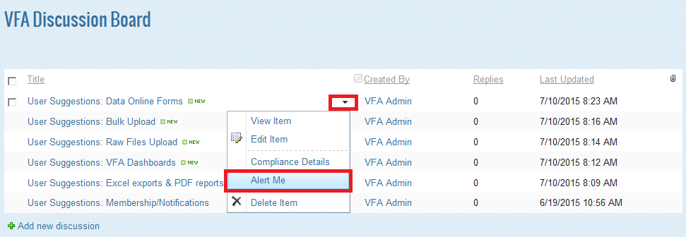
- How do I change my subscriptions or unsubscribe?
  - To manage your alerts or unsubscribe, please visit this page: http://vfa.aacc.nche.edu/connect/_layouts/MySubs.aspx. To unsubscribe, put a check mark next to the topic you would like to unsubscribe from and click “Delete”.

