Explanation of Cohort Types
- Main Cohort
The VFA Main Cohort includes all students who are new to the reporting institution in the first, fall term of the tracking period, regardless of prior postsecondary education experiences, including non-traditional fall enrollments (see below). Students included must have completed high school or equivalent, and attempted credit and/or developmental education classes for the first time at the reporting institution in the fall term of the cohort year. This would be fall 2010 term for the Six Year Cohort and fall 2014 term for the Two Year Cohort.
A student may be included if he/she is:
- New the institution in the specified fall or preceding summer terms; and
- Completed high school or equivalent, or demonstrated ability to benefit; and
- Enrolled in the fall term of the cohort year; and
- Attempted a credit and/or developmental education course.

Non-Traditional Fall Enrollment
Students with nontraditional fall enrollments (enrolled in courses that begin after the traditional fall term start date) should be included in the Main Cohort if the student’s enrollment in at least one course or learning activity starts prior to the end of the college’s traditional fall term and remains enrolled after the no-fault drop/add date for that course/educational experience.

Further cohort clarifications:
- Students may be enrolled full-time or part-time.
- Students do not need to be classified as degree- or credential-seeking.
- Students who transfer into your institution (i.e. students with prior postsecondary credits earned after high school completion at another institution) should be included if they are enrolling for the first time at your institution.
- The cohort should also include students who earned college credits during high school (such as dual enrollment) as long as this is their first enrollment at your college after receipt of the high school diploma or equivalent.
- Students who first enrolled in the summer preceding the fall term, such as those in summer bridge programs or those who began college in an early starter program, should also be included in this cohort. Of course, they must also have enrolled in the fall term.
- Students who do not have a high school diploma or equivalent, but who have a demonstrated ability to benefit (as defined by Title IV Federal financial aid eligibility) should also be included in the cohort if the fall term, or preceding summer term, is their first term at your college. They must also have enrolled in the fall term.
- The cohort assignment of a student remains the same throughout the tracking timeframe for the purpose of VFA reporting.

Do Not Include:
- Students who were enrolled exclusively in ESL courses should not be included in the Main Cohort.
- High school students dually enrolled at your institution (also referred to as dual credit) should not be included in the Main Cohort. However, if the student enrolls in your institution after the receipt of the high school diploma or equivalent, the student would then be eligible for inclusion in the cohort and the credits obtained while dually enrolled should be included in the calculation of relevant measures.
Example 1: Student A was enrolled in high school and taking two courses at your community college in the fall of 2010; this student would NOT be part of the VFA Six Year, Main Cohort (fall 2010).
Example 2: Student B has completed high school, received a diploma, and enrolled in the community college in fall 2010. Student B had previously earned, as a dually enrolled high school student, 6 credits from your community college. Student B should be included in the Main Cohort (fall 2010) and the student’s credits should count toward the appropriate measures.
Example 3: Student C has taken courses at the community college and has subsequently received a GED. In fall 2010, student C enrolled at your community college upon receipt of the GED. Student C should be included in the VFA Main Cohort and the student’s credits will count toward credit accumulation thresholds and credit hour success rates.
Inclusion Decision Tree: Main Cohort, Six Year Cohort (fall students 2010)
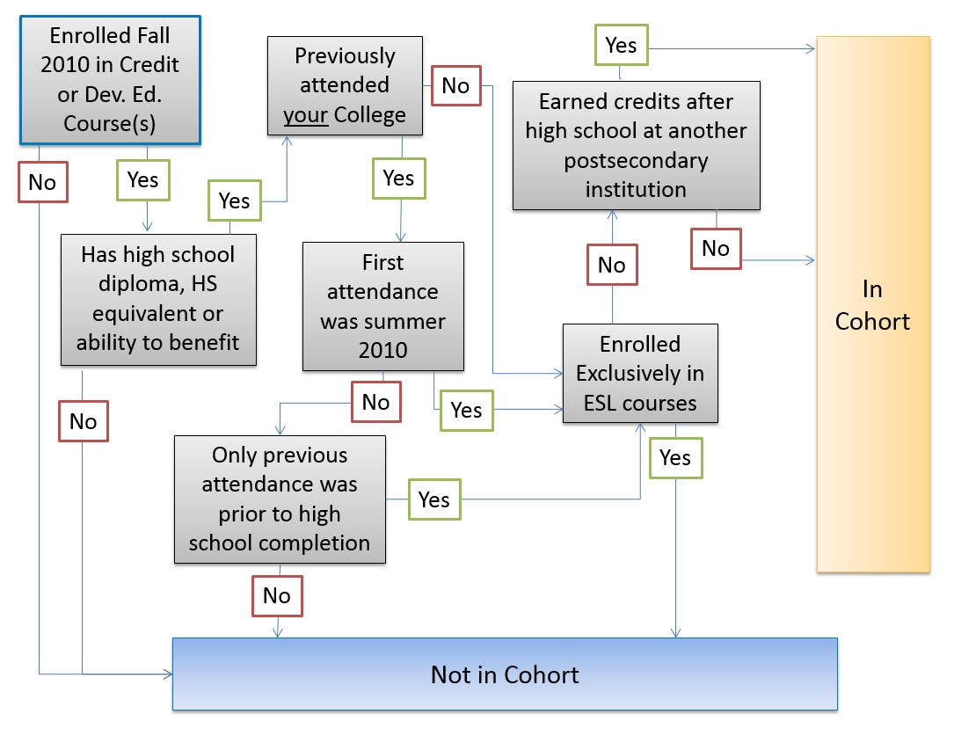
Cohort Types
Students from the two year and six year reporting timeframes will be further categorized into three cohort types:
- Main Cohort
- Credential Seeking Cohort
- First Time in College Cohort
Measure / Calculation | Definition | Important Notes
Main Cohort | All students who were enrolled in credit or developmental education classes in the fall term, had completed high school (or the equivalent), and were new to the institution regardless of prior postsecondary education experiences.  To be included in cohort, students should:  - Hold a high school diploma, GED, or other high school completion equivalent  - Enter your college for the first time since receipt of the high school diploma or equivalent during the specified fall term  - Enroll in credit or developmental education courses in the fall term  Do not include:  - Students exclusively enrolled in ESL  - High school students who are dually enrolled (concurrently enrolled) in your college. Upon graduating from high school these students are eligible to be considered for the cohort. | Students who transfer into your college (prior post-secondary experience) should be included.  Include all students, regardless of attendance intensity (full‐time/part‐time) or degree-seeking status.  Colleges should include in the cohort students who enrolled in the fall term and also attended the college in the prior summer term.  Colleges should include students who have non-traditional fall enrollments as long as the start date of the enrollment is prior to the end of the traditional fall term.  Students do not need to be classified as degree- or credential-seeking students.  Students who do not have a high school diploma or equivalent, but who have a demonstrated ability to benefit (as defined by Title IV Federal financial aid eligibility) should also be included.  If college does not verify high school completion but allows students to enroll in credit or developmental courses, include students in the Main Cohort as long as they meet all other criteria.

